MEKELLE UNIVERSITY MEKELLE INSTITUTE OF TECHNOLOGY

**DEPARTMENT OF INFORMATION TECHNOLOGY & COMPUTER SCIENCE AND ENGINEERING**

**INTERNSHIP FINAL REPORT**

**METNEE SYSTEMS PLC**

*NOV 01/2024 - JAN 30/2025 GC*

# TEAM MEMBERS

1. Amanuel Yirgalem MIT/UR/016/11
2. Esrael Teferi MIT/UR/267/11
3. Shushay Kebedew MIT/UR/276/11
4. Yared G/her MIT/UR/234/11

Contents

Table of Contents **Error! Bookmark not defined.**

CHAPTER 1 1

Background of Metnee Systems PLC 1

* 1. Brief History 1
  2. Main Products and Services 1
  3. Main Customers or End Users 2
  4. Overall Organization and Workflow 2

CHAPTER 2 4

Overall Internship Experience 4

* 1. Section of the Company Worked In 4
  2. Work Flow in the Section 4
  3. Work Tasks Executed 5
  4. Procedures and Methods Used 5
  5. Challenges Faced 6
  6. Measures Taken to Overcome Challenges 6

CHAPTER 3 7

Project Details 7

* 1. Project Title 7
  2. Short Summary of the Project 7
  3. Problem Statement & Justification 8
  4. Objective of the Project 8
  5. Literature Review 9
  6. Methodology 10
  7. Results & Discussion 11
     1. Platform Features and Functionality 11
     2. User Testing and Feedback 14
     3. Challenges Encountered 14
     4. Lessons Learned 15
     5. Future Recommendations 15

CHAPTER 4 17

Overall Benefits Gained from the Internship 17

* 1. Theoretical Knowledge 17
  2. Practical Skills 18
  3. Industrial Problem-Solving Capability 18
  4. Team Playing Skills 19
  5. Leadership Skills 19
  6. Work Ethics Understanding 19
  7. Entrepreneurship Skills 20

CHAPTER 5 21

Conclusion & Recommendation 21

Reference 22

### List Of Figures

* Figure 1. Registration feature
* Figure 2. Login feature
* Figure 3. Company job management feature
* Figure 4. Job search and filtering feature

### Acknowledgments

We sincerely thank the Almighty for granting us the strength, guidance, and opportunity to complete our internship at **Metnee Systems PLC**. This experience has been a transformative journey, allowing us to apply our academic knowledge to real-world software development challenges.

We are deeply grateful to our company coordinator, **Mr. Daniel**, for his unwavering support, expert guidance, and constructive feedback throughout this internship. His mentorship has been instrumental in shaping our technical and professional skills, and we truly appreciate his dedication and encouragement.

Our heartfelt appreciation also goes to our colleagues and team members for their collaboration, support, and willingness to share their expertise. Working alongside such talented professionals has been both inspiring and educational, making our internship experience even more rewarding.

Lastly, we extend our sincere gratitude to Metnee Systems PLC for providing us with an excellent learning environment and the opportunity to grow as aspiring professionals. This internship has been a stepping stone toward our future careers, and we are incredibly thankful to everyone who contributed to making it a valuable and enriching experience.

# CHAPTER 1.

## Background of Metnee Systems PLC

#### Brief History

Metnee Systems PLC is a leading technology company specializing in software development, IT consulting, and digital transformation services. Since its inception, the company has been committed to delivering innovative, high-quality, and scalable solutions tailored to the unique needs of businesses across various industries, including finance, healthcare, education, and e-commerce.

With a strong focus on cutting-edge technologies, Metnee Systems PLC has played a pivotal role in helping organizations streamline their operations, enhance efficiency, and embrace digital transformation. The company has built a reputation for excellence through its expertise in cloud computing, artificial intelligence, cybersecurity, and enterprise software development.

By fostering a culture of innovation and continuous improvement, Metnee Systems PLC has established long-term partnerships with global clients, providing them with customized solutions that drive business growth and competitiveness in the ever- evolving technology landscape.

#### Main Products and Services

Metnee Systems PLC offers a diverse range of technology-driven products and services designed to meet the evolving needs of businesses and industries. These include:

* + - **Custom Software Development:** Tailored software solutions that address specific business challenges and optimize operational efficiency.
    - **IT Consulting:** Expert guidance and strategic planning to help organizations navigate complex technological landscapes and achieve their digital goals.
    - **System Integration:** Seamless integration of various IT systems and applications to enhance interoperability, security, and performance.
    - **Web and Mobile Application Development:** End-to-end development of responsive web applications and feature-rich mobile apps for Android and iOS platforms.
    - **Cloud-Based Solutions:** Scalable and secure cloud computing services, including cloud migration, deployment, and management, to improve accessibility and operational flexibility.
    - **Cybersecurity Services:** Comprehensive security assessments, threat mitigation strategies, and data protection solutions to safeguard businesses from cyber threats.
    - **Artificial Intelligence & Machine Learning:** AI-driven solutions that enhance automation, data analysis, and predictive insights for improved decision-making.
    - **Enterprise Software Solutions:** Development of ERP, CRM, and other enterprise applications to streamline business processes and enhance productivity.

By continuously evolving and adopting emerging technologies, Metnee Systems PLC remains at the forefront of technological advancements, delivering solutions that empower businesses to succeed in the digital era.

#### Main Customers or End Users

Metnee Systems PLC caters to a wide range of clients, including businesses, government institutions, startups, and private organizations seeking innovative software solutions.

The company’s clientele spans multiple industries such as healthcare, finance, education, logistics, and e-commerce, where digital transformation, operational efficiency, and automation are critical for success.

* + - **Enterprises and Corporations:** Companies requiring customized software solutions to enhance workflow, productivity, and digital innovation.
    - **Government Agencies:** Institutions seeking robust IT infrastructure, secure data management, and automation services to improve public sector operations.
    - **Startups and SMEs:** Small and medium-sized businesses aiming to leverage technology for scalability, market expansion, and enhanced customer engagement.
    - **Educational Institutions:** Schools, universities, and e-learning platforms looking for digital education tools, content management systems, and virtual learning environments.

By providing tailored software solutions, Metnee Systems PLC ensures that its customers achieve their strategic objectives, operational efficiency, and long-term sustainability.

#### Overall Organization and Workflow

Metnee Systems PLC is structured into multiple specialized departments that collaborate to ensure seamless project execution and service delivery. The organization follows a

structured workflow to maintain efficiency, transparency, and innovation across all projects.

* + - **Software Development:** Responsible for designing, developing, and deploying software applications tailored to client needs.
    - **IT Support & Maintenance:** Ensures continuous system monitoring, troubleshooting, and upgrades for optimal performance.
    - **Project Management:** Oversees project planning, execution, and coordination between teams to ensure timely delivery and quality assurance.
    - **Research & Innovation:** Focuses on emerging technologies such as AI, blockchain, and IoT to develop innovative solutions for clients.

The company follows an **Agile methodology**, allowing for iterative development, continuous feedback, and adaptability to changing client requirements. Project workflows typically involve:

1. **Requirement Analysis:** Gathering client needs, defining project scope, and outlining objectives.
2. **Planning & Design:** Creating system architectures, prototypes, and defining technical specifications.
3. **Development & Integration:** Coding, testing, and integrating various system components.
4. **Quality Assurance & Testing:** Conducting rigorous testing to identify and resolve issues before deployment.
5. **Deployment & Support:** Launching the final product and providing ongoing maintenance, support, and updates.

By fostering a collaborative and client-focused approach, Metnee Systems PLC ensures that its software solutions align with business goals, industry standards, and emerging technological trends.

# CHAPTER 2

## Overall Internship Experience

#### Section of the Company Worked In

During our internship at Metnee Systems PLC, we were assigned to a dedicated development team working on the **Sheqlee project**, a freelancing marketplace similar to Upwork. Our team comprised two frontend developers, one mobile app developer, and one backend developer, each playing a vital role in the system's overall architecture and implementation.

We were responsible for building the entire system from scratch, including designing user interfaces, implementing backend logic, and developing the mobile application. The project required close collaboration and efficient task management, ensuring that each component integrated seamlessly.

Our team operated under the supervision of an assigned company coordinator who provided guidance, monitored our progress, and facilitated smooth communication between different teams. Tasks were distributed based on expertise, with frontend developers handling web-based interfaces, the mobile developer focusing on app functionality, and the backend developer managing database operations and API development.

#### Work Flow in the Section

The software development process followed an ***Agile methodology***, enabling iterative development, continuous improvement, and adaptability to changing project requirements. Our workflow included:

* + - Daily stand-up meetings to discuss progress, challenges, and upcoming tasks.
    - Sprint planning to define short-term development goals and deliverables.
    - Collaborative coding and code reviews to maintain code quality and efficiency.
    - Continuous integration and deployment (CI/CD) to ensure rapid and seamless updates.
    - Testing and debugging cycles before deploying new features or updates.
    - Regular feedback sessions to incorporate improvements based on testing and user feedback.

#### Work Tasks Executed

Throughout the internship, we actively contributed to the development and improvement of the Sheqlee platform. Our key tasks included:

##### Frontend Development:

* + - * Designed and developed responsive web interfaces using React.
      * Implemented interactive UI components to enhance user experience.
      * Integrated RESTful APIs for real-time data handling.

##### Backend Development:

* + - * Developed RESTful APIs and database schemas.
      * Managed authentication, user roles, and authorization processes.
      * Optimized database queries for performance improvement.

##### Mobile App Development:

* + - * Developed core mobile application features using Flutter and Dart.
      * Integrated real-time notifications and in-app messaging functionalities.
      * Ensured app compatibility across multiple device resolutions.

##### Quality Assurance & Optimization:

* + - * Debugged and optimized application performance.
      * Conducted UI/UX improvements for better usability.
      * Performed integration testing to ensure seamless cross-platform functionality.

#### Procedures and Methods Used

To ensure smooth project execution and maintain high-quality code, we employed the following methodologies:

* + - **Version Control with Git:** Used GitHub for version control, branching, and team collaboration.
    - **Agile Development (Scrum Framework):** Followed iterative sprints, daily scrums, and retrospective meetings.
    - **Unit Testing & Debugging:** Employed Jest and Flutter Test for unit testing to validate code functionality.
    - **Continuous Integration & Deployment (CI/CD):** Implemented automated deployment pipelines for efficient product updates.

#### Challenges Faced

Throughout the internship, we encountered various challenges, including:

* + - **Adapting to New Technologies:** Learning and implementing new frameworks such as Flutter and advanced React patterns.
    - **Understanding Complex Codebases:** Navigating and contributing to an evolving large-scale project with multiple dependencies.
    - **Managing Multiple Tasks:** Balancing multiple development responsibilities within tight deadlines.
    - **Debugging Cross-Platform Issues:** Addressing inconsistencies between the web and mobile versions.

#### Measures Taken to Overcome Challenges

To address these challenges, we employed the following strategies:

* + - **Self-Learning & Research:** Utilized online courses, documentation, and coding tutorials to strengthen technical proficiency.
    - **Seeking Mentorship:** Regularly consulted senior developers for guidance and problem-solving approaches.
    - **Task Prioritization:** Used project management tools like Jira to track tasks and allocate time effectively.
    - **Collaboration & Code Reviews:** Engaged in peer reviews and pair programming to improve code quality and resolve issues efficiently.

By actively engaging in a structured learning process, we successfully navigated the complexities of software development while gaining valuable real-world experience.

* 1. **Project Title**

# CHAPTER 3

## Project Details

Development of **Sheqlee** – A Comprehensive, Cross-Platform Freelancing Marketplace for Connecting Businesses and Talents.

#### Short Summary of the Project

**Sheqlee** is an innovative, all-encompassing freelancing marketplace designed to address the dynamic and diverse needs of both businesses and freelancers. The platform serves as a bridge, connecting companies in need of skilled professionals with freelancers seeking job opportunities, offering a seamless experience across both web and mobile platforms. Sheqlee allows users to create customized accounts, either as companies or freelancers, ensuring that each user group benefits from tailored features and tools to enhance their experience. Companies can efficiently post job listings, manage applications, communicate with potential hires, and monitor project progress, while freelancers have the ability to search for job opportunities, filter listings by skillset, apply to relevant positions, and subscribe to notifications based on categories, tags, or specific companies.

The platform emphasizes more than just job matching; it is designed to offer a comprehensive and transparent freelancing ecosystem. Sheqlee integrates cutting-edge security features, such as secure authentication, escrow-based payment systems, and real-time communication tools, to foster trust and ensure the integrity of transactions between freelancers and clients. The platform's goal is to provide a dynamic and scalable environment that supports a variety of freelance professions across different industries, ensuring that users can easily engage with the platform from anywhere, on any device.

By leveraging modern development frameworks and adopting a user-centric approach, Sheqlee aims to create an intuitive, flexible, and accessible digital workspace. It addresses the evolving demands of the freelancing market, creating a robust and efficient platform where businesses and freelancers can collaborate effectively, manage projects effortlessly, and build long-term, successful professional relationships. Sheqlee is positioned to revolutionize the freelancing industry by providing an inclusive platform

that empowers both freelancers and businesses to thrive in an ever-changing digital landscape.

#### Problem Statement & Justification

Many freelancers and businesses struggle to find a reliable, secure, and cost-effective marketplace to collaborate efficiently. Existing platforms often impose high service fees, making it challenging for freelancers to maximize their earnings while also creating financial burdens for companies looking to hire skilled professionals. Additionally, these platforms frequently lack intuitive job discovery mechanisms, leading to difficulty in matching freelancers with suitable projects based on their expertise and preferences.

Moreover, trust issues between freelancers and companies persist due to inadequate verification systems, inefficient dispute resolution processes, and a lack of secure payment protection. Sheqlee addresses these pain points by offering a user-friendly, structured, and transparent freelancing ecosystem. The platform enhances job matching efficiency through advanced filtering and recommendation systems while ensuring secure transactions through milestone-based payments and escrow services.

By integrating these features, Sheqlee fosters a more inclusive, scalable, and interactive freelancing marketplace where businesses can seamlessly connect with the right talent, and freelancers can access meaningful opportunities in a well-regulated and reliable digital workspace.

#### Objective of the Project

The primary objective of Sheqlee is to develop a comprehensive, scalable, and user- friendly freelancing platform that facilitates seamless interactions between clients and skilled professionals. The key objectives include:

* **Secure User Authentication:** Implement a highly secure authentication system, including role-based access for companies and freelancers, multi-factor authentication (MFA), and encrypted user credentials.
* **Job Management for Companies:** Provide businesses with powerful tools to create job postings, manage applications, communicate with freelancers, and track project progress effectively.
* **Advanced Job Discovery for Freelancers:** Offer AI-powered job recommendations, sophisticated filtering options, and an intuitive search system that allows freelancers to find the most relevant opportunities based on their expertise, budget, and location preferences.
* **Job Application and Subscription System:** Enable freelancers to apply for jobs seamlessly, receive notifications for newly posted opportunities, and subscribe to preferred job categories, skill tags, and specific employers.
* **Cross-Platform Accessibility:** Ensure a smooth and uniform experience across web and mobile applications using React for the frontend, Flutter for mobile applications, and Node.js for backend operations.
* **Integrated Secure Payment System:** Implement milestone-based payments, escrow services, and multiple payment gateway options to ensure secure and timely transactions for both clients and freelancers.
* **Performance Analytics and Reporting:** Equip companies and freelancers with data-driven insights, such as application trends, project completion rates, and client-freelancer interaction metrics, to help them make informed decisions.

By incorporating these core functionalities, Sheqlee aims to simplify the freelancing experience while upholding high standards of security, transparency, efficiency, and accessibility, ultimately creating a more effective and sustainable freelancing marketplace.

#### Literature Review

A literature review was conducted to examine leading freelancing platforms such as Upwork, Fiverr, and Freelancer, alongside academic research and industry reports on digital labor markets. The key insights from these sources are as follows:

* Success Factors: Successful freelancing platforms commonly emphasize a simplified user experience, robust verification systems, effective dispute resolution mechanisms, transparent job posting processes, and secure payment methods that foster trust between clients and freelancers [1,3].
* Challenges Identified: Research highlights several challenges within freelancing platforms, including high service fees, inconsistent freelancer quality, inadequate verification processes, ineffective job matching algorithms, and difficulties in dispute resolution [4, 5].
* Industry Best Practices: Best practices observed in modern freelancing ecosystems involve adopting scalable cloud-based architectures, implementing AI-powered job recommendations to improve freelancer-client matching, leveraging blockchain-based payment solutions for enhanced security, and utilizing advanced authentication techniques such as biometric verification to increase trust and platform credibility [6].
* Emerging Trends: The gig economy continues to expand due to increasing demand for specialized skills and the rise of remote work. Emerging technologies,

such as decentralized marketplaces and AI-driven talent-matching systems, are shaping the future of freelancing platforms, ensuring more efficiency and transparency [5, 6].

By integrating these insights, Sheqlee aims to enhance usability while addressing the common challenges faced in existing freelancing ecosystems, ensuring a more efficient, transparent, and secure digital work environment.

#### Methodology

**Sheqlee** was developed using the **Agile methodology**, ensuring an iterative and collaborative development process. The key phases include:

* **Requirement Analysis:** A thorough investigation of market needs and industry trends was conducted, identifying pain points in existing freelancing platforms. Extensive user research, competitor analysis, and stakeholder discussions helped define Sheqlee’s core features and objectives.
* **System Design:** The platform’s architecture was structured to support scalability, performance, and security. Wireframes and interactive prototypes were developed to map out user interactions. The backend infrastructure was designed using cloud-based solutions to optimize efficiency and ensure seamless data handling.

##### Development:

* + **Frontend:** Built with React.js to deliver an interactive and dynamic user interface, ensuring a responsive experience across different devices.
  + **Mobile App:** Developed using Flutter, enabling a unified cross-platform experience with smooth UI components and real-time updates.
  + **Backend:** Implemented using Node.js with Express.js, ensuring efficient API handling, high-performance database operations, and scalable microservices architecture.

##### Testing & Debugging:

* + **Unit Testing:** Conducted to validate the functionality of individual components and ensure reliability.
  + **Integration Testing:** Implemented to verify seamless interactions between frontend, backend, and database components.
  + **User Acceptance Testing (UAT):** Engaged real users in testing to collect feedback, improve user experience, and refine system functionalities.
  + **Security Testing:** Ensured data integrity, secure authentication, and protection against vulnerabilities like SQL injection and cross-site scripting (XSS).

#### Results & Discussion

The **Sheqlee platform** successfully implemented its key functionalities, delivering a robust and user-friendly freelancing experience. Below is a breakdown of platform capabilities, user feedback, and challenges encountered.

#### Platform Features and Functionality

##### Secure Login and Registration

* Role-based authentication allowing users to sign up as companies or freelancers.
* Secure authentication mechanisms, including email verification and password encryption.
* OAuth and third-party login options (Google) for seamless access.

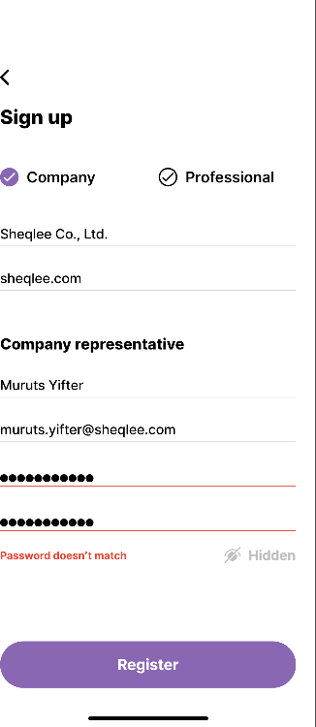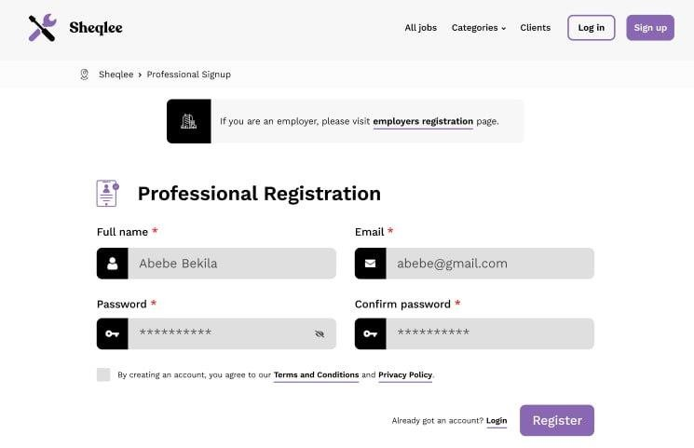

Figure 1. Registration feature

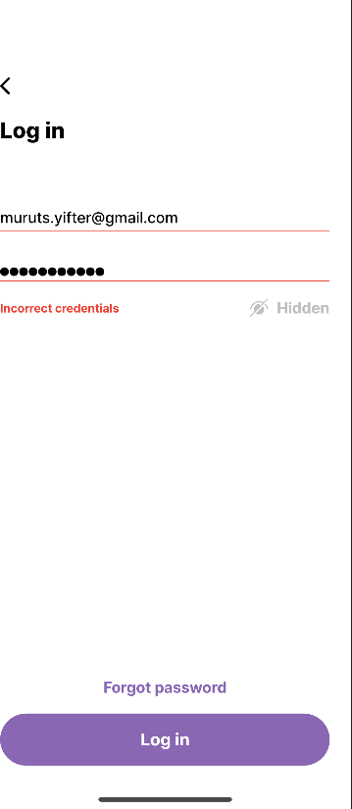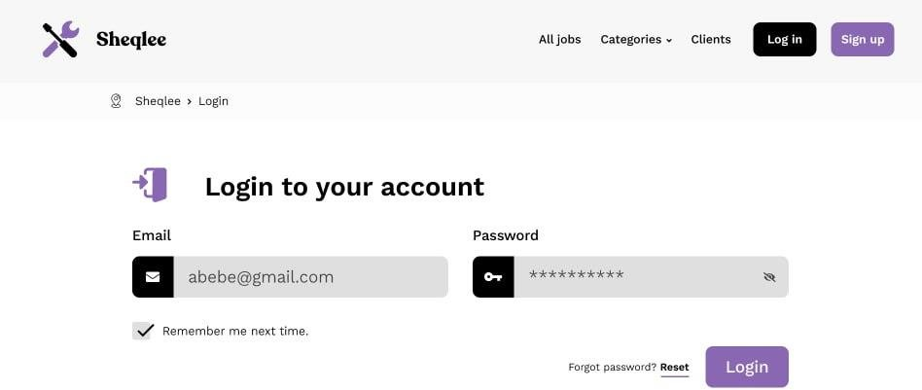

Figure 2. Login feature

##### Job Management for Companies

* Job posting system allowing companies to list available projects with detailed descriptions.
* Application management tools for tracking freelancer proposals.
* Job status updates to manage the hiring process effectively.

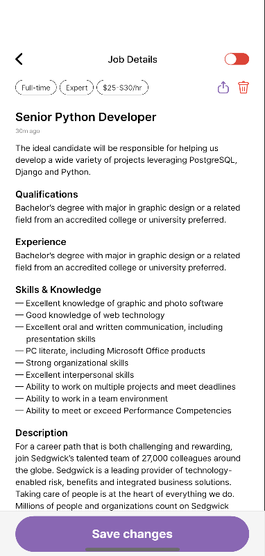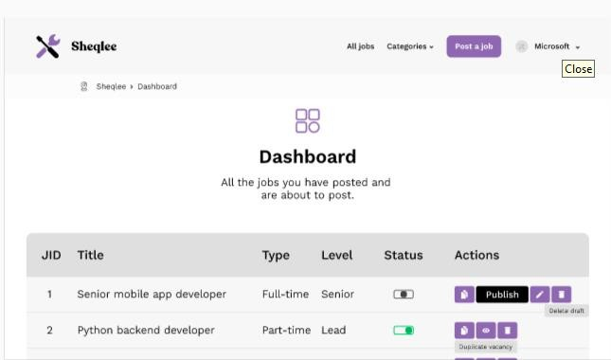

Figure 3. Company job management feature

##### Job Search and Application for Freelancers

* Comprehensive job listings with detailed project descriptions, employer information, and budgets.
* Advanced search and filtering options for finding jobs based on categories, skills, and budgets.
* Effortless application process, allowing freelancers to submit proposals seamlessly.

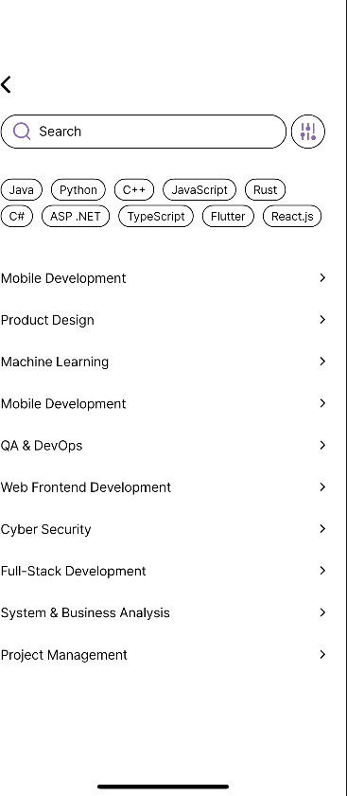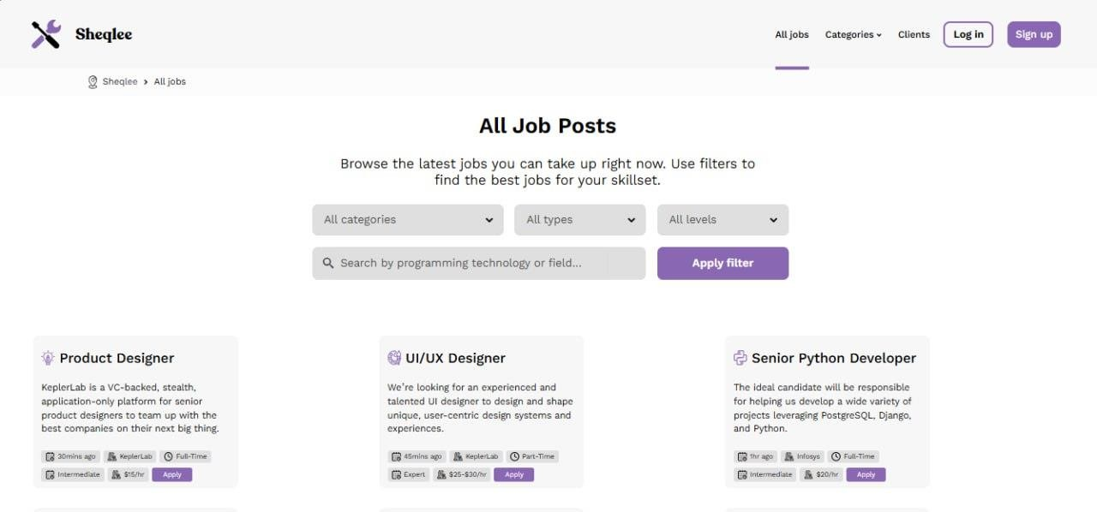

Figure 4. Job search and filtering feature

##### Subscription to Categories, Tags, and Companies

* Freelancer subscriptions to job categories, skill tags, and company profiles.
* Personalized notifications when relevant jobs are posted.
* Employer engagement tools for building freelancer talent pools.

#### User Testing and Feedback

A user testing phase was conducted with freelancers, companies, and industry experts. Key findings include:

* + - * **High Usability Scores**: 90% of participants rated the platform as intuitive and easy to navigate.
      * **Positive Freelancer Engagement**: Users appreciated the job search and filtering system, which simplified job discovery.
      * **Strong Market Potential**: Experts noted the structured job management and subscription features as a competitive advantage.

#### Challenges Encountered

##### Technical Challenges

* + Ensuring secure authentication mechanisms while maintaining user convenience.
  + Optimizing the subscription and notification system for real-time updates.

##### User Adoption

* + Encouraging users to transition from existing platforms required effective marketing.
  + Trust-building measures such as enhanced freelancer verification was necessary.

##### Scalability

* + Managing a growing user base required optimized server-side logic and cloud infrastructure investments.

#### Lessons Learned

Key takeaways from the project include:

* + - * User-Centric Design is Essential – Prioritizing ease of use and accessibility enhances platform adoption.
      * Agile Methodology Enables Continuous Improvement – Iterative development cycles facilitated refinements based on user feedback.
      * Collaboration Drives Success – Effective teamwork across frontend, backend, and mobile teams ensured smooth development.

#### Future Recommendations

To enhance Sheqlee’s impact and scalability, the following improvements are

recommended:

##### Expand Payment Options

* + Introduce cryptocurrency payments to cater to a wider audience.
  + Partner with local payment providers to improve accessibility.

##### Enhance Security Measures

* + Implement two-factor authentication (2FA) for added account security.
  + Conduct regular security audits to identify vulnerabilities.

##### Improve Scalability

* + Optimize database queries and server-side logic to handle increasing traffic.
  + Invest in cloud-based hosting solutions.

##### Introduce AI-Driven Job Matching

* + Develop automated job recommendations based on freelancer skills and past applications.

# CHAPTER 4

## Overall Benefits Gained from the Internship

The internship at Metnee Systems PLC was a transformative experience that provided us with a wealth of knowledge, practical skills, and professional growth opportunities.

Working on the Sheqlee project allowed us to apply theoretical concepts to real-world challenges, collaborate with industry experts, and develop a deeper understanding of the software development lifecycle. This section elaborates on the key benefits gained during the internship, categorized into theoretical knowledge, practical skills, industrial problem-solving capabilities, team-playing skills, leadership skills, work ethics understanding, and entrepreneurship skills.

#### Theoretical Knowledge

The internship significantly enhanced our theoretical understanding of software development practices and principles. Key areas of growth include:

##### Agile Development Practices

* + - * We developed a strong understanding of Agile methodologies, particularly the Scrum framework, which emphasizes iterative development, collaboration, and continuous improvement.
      * Participating in daily stand-up meetings, sprint planning sessions, and retrospectives reinforced the importance of adaptability and teamwork in meeting project goals.
      * We learned how to break down complex tasks into manageable user stories, prioritize them based on business value and technical feasibility, and ensure efficient task execution.

##### System Architecture and Design Patterns

* + - * The internship provided hands-on exposure to system architecture principles, focusing on designing scalable and maintainable software systems.
      * We gained practical experience in implementing design patterns such as MVC (Model-View-Controller) and RESTful API architecture, both essential for building modular and high-performance applications.
      * Understanding the interaction between frontend, backend, and database components deepened our appreciation for well-structured software design and improved our ability to develop efficient, cohesive systems.

#### Practical Skills

The internship provided ample opportunities to refine our technical skills and gain proficiency in modern development tools and frameworks. Key practical skills acquired include:

##### Mobile App Development Using Flutter

* + - * We developed expertise in Flutter, a cross-platform framework for building high-performance mobile applications.
      * Working on the Sheqlee mobile app allowed us to master Dart programming, widget-based UI design, and state management techniques.
      * We also gained experience in integrating third-party libraries and APIs to enhance app functionality and improve user experience.

##### Debugging and Testing Capabilities

* + - * The internship strengthened our ability to identify, diagnose, and resolve software bugs efficiently.
      * We became proficient in using Chrome DevTools and Flutter Debugger to troubleshoot issues in both web and mobile applications.
      * We gained hands-on experience in writing unit tests and conducting integration testing to ensure the platform's reliability, stability, and performance.

#### Industrial Problem-Solving Capability

Working on the **Sheqlee** project allowed us to tackle real-world business challenges and develop innovative solutions. Key achievements include:

##### Developing Solutions for Real-World Business Problems

* Designed and implemented features that addressed critical freelancing industry challenges, including secure payments, transparent communication, and efficient job matching.
* Collaborated with the team to solve complex technical issues, such as optimizing database queries and ensuring cross-platform compatibility, enhancing our problem-solving skills.

##### Implementing Efficient Algorithms for Data Processing

* Gained experience in designing and implementing algorithms to process large datasets, including user profiles, job postings, and transaction records.
* Optimized algorithms for performance and scalability, deepening our understanding of data structures and computational efficiency.

#### Team Playing Skills

The internship emphasized the importance of collaboration and teamwork in achieving project success. Key experiences include:

##### Collaborating with Cross-Functional Teams

* Worked alongside frontend, backend, and mobile developers, enhancing our ability to communicate effectively and leverage diverse skill sets to achieve common goals.
* Learned to navigate different perspectives and work styles, fostering a cohesive and productive team environment.

##### Participating in Agile Practices

* Actively engaged in daily stand-ups, sprint planning, and retrospectives, reinforcing the value of transparency, accountability, and continuous improvement in team dynamics.
* Gained experience in using collaboration tools such as **Jira** and **Trello** to track progress and manage tasks efficiently.

#### Leadership Skills

The internship provided opportunities to take on leadership roles and contribute to the

team’s success. Key experiences include:

##### Taking Initiative in Debugging Sessions

* Proactively identified and resolved technical issues, often leading debugging sessions to ensure timely resolution of critical bugs.
* Strengthened our ability to think critically and make informed decisions under pressure.

##### Assisting Junior Interns

* Mentored junior interns by sharing knowledge, providing guidance on coding best practices, and assisting with problem-solving.
* Enhanced our ability to communicate complex concepts clearly and foster a supportive learning environment.

#### Work Ethics Understanding

The internship instilled a strong sense of professionalism and work ethic. Key takeaways include:

##### Maintaining Professionalism in a Corporate Setting

* Learned the importance of punctuality, accountability, and respect in a professional environment.
* Adhering to company policies and maintaining a positive attitude contributed to a productive and harmonious workplace.

##### Adhering to Deadlines and Project Requirements

* Successfully met tight deadlines while maintaining high-quality standards, making it both a challenging and rewarding experience.
* Developed effective time management strategies, such as prioritizing tasks and breaking them into smaller, manageable steps.

#### Entrepreneurship Skills

The internship provided invaluable insights into the entrepreneurial side of software development. Key takeaways include:

##### Developing and Marketing a Product Effectively

* We gained hands-on experience in the complete product development cycle, from ideation and design to implementation and deployment.
* A significant lesson was understanding the role of user feedback and market research in refining product features to meet user needs.

##### Understanding Client Requirements and Business Needs

* Collaborating closely with stakeholders to define project requirements and align them with business objectives enhanced our understanding of the client- developer dynamic.
* We learned how to balance technical feasibility with business priorities, ensuring that our solutions delivered meaningful value to the client.

# CHAPTER 5

## Conclusion & Recommendation

Our internship at Metnee Systems PLC was a highly enriching experience that strengthened our technical and professional skills. Through hands-on exposure to real- world software development, we enhanced our ability to apply theoretical knowledge in practical settings. The internship also allowed us to work closely with industry experts, refining our problem-solving abilities, collaboration skills, and adaptability in an Agile work environment.

We recommend future interns actively engage in learning opportunities by taking initiative in problem-solving and embracing collaboration with teammates. Utilizing available resources, such as online learning platforms, industry documentation, and mentorship from experienced professionals, will significantly enhance their experience. Additionally, maintaining strong work ethics, meeting deadlines efficiently, and continuously improving technical proficiency will ensure a more rewarding and impactful internship.

Overall, the Sheqlee project provided an excellent foundation for understanding the complexities of real-world software development. The knowledge, skills, and experience gained will be instrumental in our professional growth and future career endeavors.

### Reference

1. Upwork, "Upwork Annual Report 2023," Upwork Inc., 2023. [Online]. Available: [https://www.upwork.com.](https://www.upwork.com/) [Accessed: Feb. 12, 2025].
2. Fiverr, "Freelance Services Marketplace Overview," Fiverr International Ltd., 2023. [Online]. Available: [https://www.fiverr.com.](https://www.fiverr.com/) [Accessed: Feb. 12, 2025].
3. Freelancer, "Freelancer 2023 Insights Report," Freelancer Technology Pty Limited, 2023. [Online]. Available: [https://www.freelancer.com.](https://www.freelancer.com/) [Accessed: Feb. 13, 2025].
4. J. Berg, M. Furrer, E. Harmon, U. Rani, and M. S. Silberman, *Digital Labour Platforms and the Future of Work: Towards Decent Work in the Online World*, International Labour Organization, 2018.
5. A. Kassi and V. Lehdonvirta, "Online Labour Index: Measuring the Online Gig Economy for Policy and Research," *Technological Forecasting and Social Change*, vol. 137, pp. 241-248, 2018.
6. M. Chen, "Blockchain and AI in the Gig Economy: Opportunities and Challenges," *IEEE Access*, vol. 9, pp. 126500-126512, 2021.